FeatureFlow
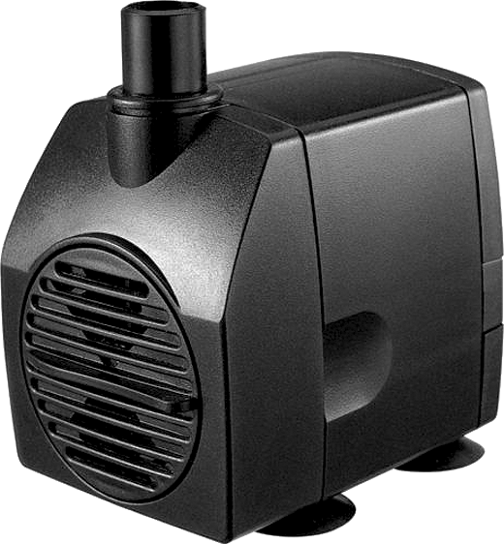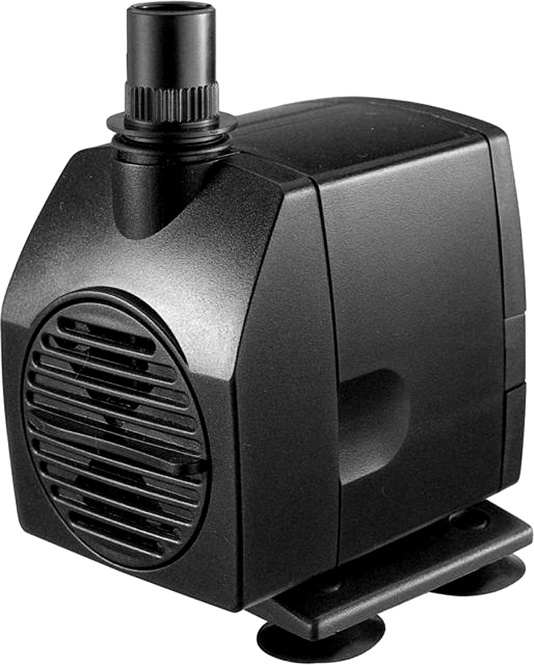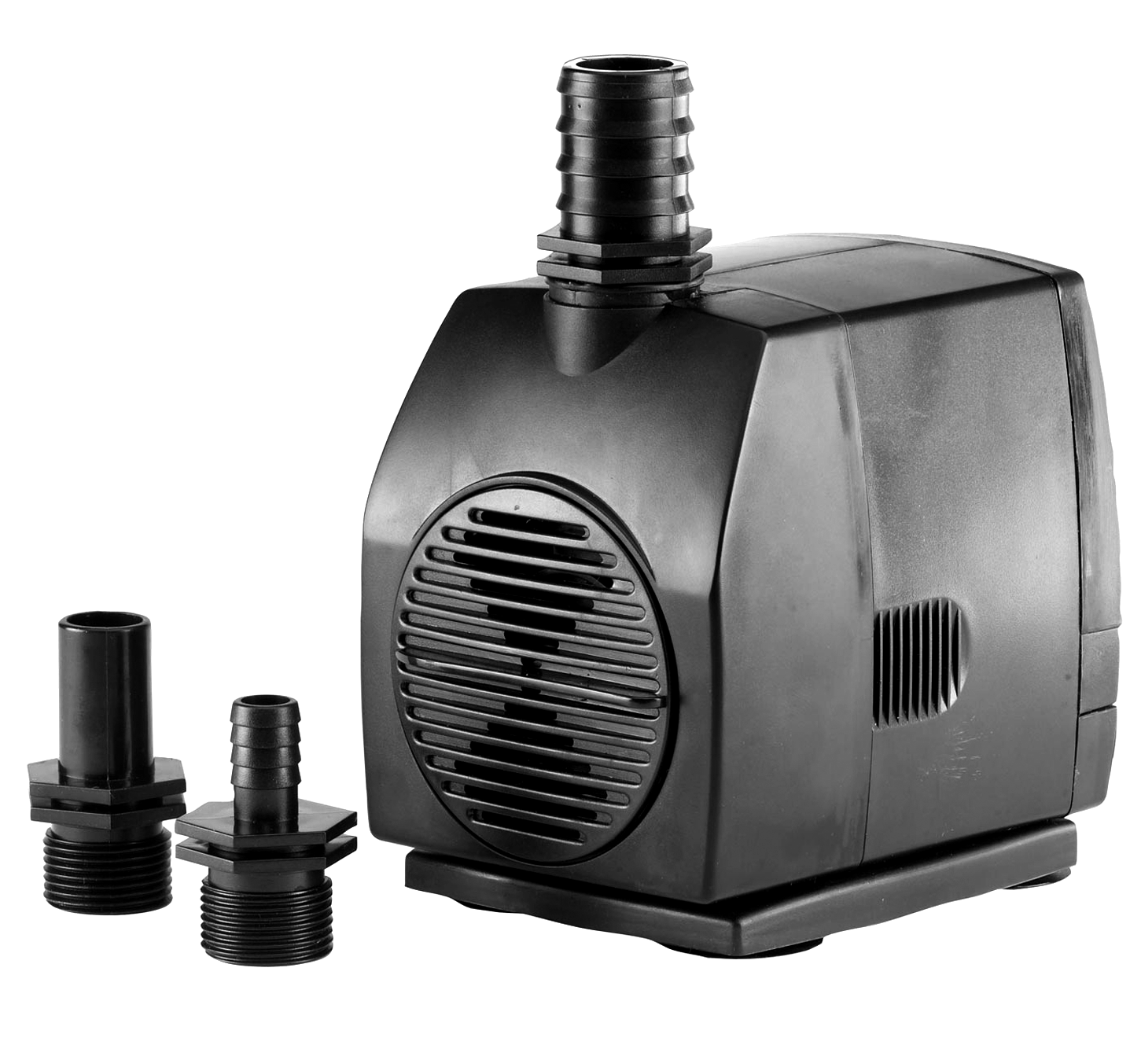


Water Feature Pumps

Model | Power Rating | Max Flow  (Lts per hr) | Max.  Head | Dimension  LWH mm | Hosetail  Supplied mm
PXFEAT0350B | 6w | 350 LPH | 0.70m | 57 x 41 x 46 | 8 / 12mm
PXFEAT0450B | 5w | 450 LPH | 0.95m | 61 x 43 x 45 | 8 / 12mm
PXFEAT0750B | 10w | 700 LPH | 1.40m | 71 x 51 x 57 | 8 / 12mm
PXFEAT1000B | 14w | 950 LPH | 1.80m | 74 x 55 x 67 | 8 / 12mm
PXFEAT1200B | 20w | 1200 LPH | 2.00m | 87 x 59 x 74 | 12 / 20mm
PXFEAT1500B | 25w | 1500 LPH | 2.50m | 95 x 69 x 90 | 12 / 20mm
PXFEAT2000B | 45w | 2000 LPH | 3.00m | 106 x 75 x 102 | 12 / 20mm
PXFEAT3000B | 70w | 3000 LPH | 3.50m | 126 x 95 x 120 | 12 / 20 / 25mm
PXFEAT4000B | 99w | 4000 LPH | 4.00m | 126 x 95 x 124 | 12 / 20/ 25mm
PXFEAT5000B | 190w | 5000 LPH | 5.00m | 208 x 109 x 130 | 12 / 20 /25mm

All pumps come complete with 10m electrical cable and have rated voltage of 220-240V, 50Hz

Introduction
Congratulations on choosing a pondXpert pump. Used correctly your pump will provide years of reliable service. This pump is designed to push water through to a water feature and can be used indoor or outdoors. Pump is also suitable for indoor aquariums.

Your pump must always be immersed in fresh water before it is switched on.

General safety Instructions
Read and observe all of the instructions clearly before installing, connecting and operating the pump. Make sure the pump is securely and correctly installed before switching on.
Always disconnect the pump when not in use and when carrying out maintenance.
Always disconnect all underwater equipment before starting to handle, maintain, repair or install any aquatic equipment. The appliance is not intended for use by persons (including children) with reduced physical, sensory or mental capabilities, or lack of experience and knowledge, unless they have been given supervision or instruction concerning use of the appliance by a person responsible for their safety.

FeatureFlow

General safety Instructions (cont)
Children should be supervised to ensure that they do not play with the appliance. For safety reasons, servicing or repair of this item should only be carried out by pondXpert. Never hang or carry the pump by the power cord.
Ensure electrical cord loops below the electrical outlet to form a “Drip Loop” this will prevent water from running down the cord into the electric supply.
Do not operate the pump with a damaged cord or plug. The supply cord of the appliance cannot be replaced. If the electrical cord is damaged the product should be scrapped.

Safety and Electrical Connections
This unit is waterproof and should be situated safely underwater.
Take care to ensure that you can easily lift your pump out of the water for routine maintenance. Do not pick your pump up by the electrical cable but by the main body/ cage of the pump.

Always disconnect any electrical equipment around the pump before starting to handle, maintain, repair or install the item. The pump is electrically operated so great care must be taken during installation and operation – the following safety guidelines must be carefully followed.

Each pump is supplied with a 10 metre length of 3 core electrical cable which is permanently connected to the pump.


The wires in the mains electrical lead are coloured in accordance with the
following code:
BLUE – Neutral (marked with an “N” in most terminal connections)
BROWN – LIVE (marked with an “L” in most terminal connections)
GREEN/YELLOW – EARTH (marked “E” or in most terminal connections)
1st January 2005 revised Building Regulations for England and Wales
Installing this product in the garden is classified as ‘notifiable’. The Regulations now require you to tell your local authority building control department that you intend to install this product before installation. Your local authority will let you know how you can get your installation approved.

The termination to the mains supply should be permanent, inside a dry weatherproof enclosure, through a double pole switched fused spur with a minimum contact gap of 3mm – (disconnected) to BS 3676 – and fitted with a 3 or 5 amp fuse.
Exposed cable runs should be sensibly positioned, and protected if necessary by armoured conduit. A 10mA or 30mA Residual Current Circuit Breaker (RCD) MUST be fitted to the mains supply. Permanent installations to the mains supply (hard wiring) must comply with the regulations of the local electricity authority which may stipulate the use of metal or plastic conduit to protect the cable. If in any doubt about wiring to the mains supply contact a qualified electrician or your local electricity authority.
Protect from frost. In cold winter weather the unit may be switched off. It should then be drained of water, removed (if possible) from its installation and stored in a dry, frost-protected area.

FeatureFlow

Directions for use

Installation
Once installed and attached to the electrical supply water will flow through the pump as the pump’s impellor draws in water. Your pump is supplied with adaptors allowing connection of different gauge hose (see table for adaptors that should be supplied with unit).

Water Flow Regulation
The regulator situated on the front of the pump can be rotated to reduce flow if necessary.

Maintenance
Your pump performance will be reduced if the water intake is restricted in any way. Occasionally large solids may block the water intake grid holes in the front housing surrounding the pump – these should be carefully wiped away.

To clean the pump more thoroughly: first disconnect the pump from the electricity supply and carefully remove the pump from the water.
You will need to remove the front housing to get to the pump impellor. Gently remove any dirt/debris using clean water and a small brush and reassemble.

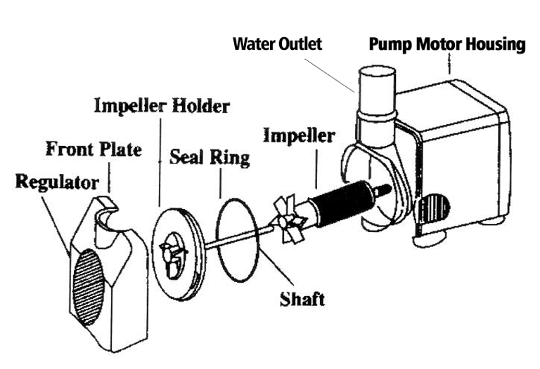

Troubleshooting
If your pump flow performance slows or stops then switch off the power and check to see if the front water intake area of the pump is blocked. If this is clear then open up the pump as shown above and check to see if you can turn the impellor manually. If the impellor turns but the pump still does not work then this may be a motor problem – the pump will need to be repaired by the manufacturer.

Limited Warranty
This product is guaranteed for a period of 12 months (excluding rotor/impellor assembly) from the date of purchase for material or manufacturing defects. The guarantee covers the substitution of defective parts. However, the guarantee is considered null and void in the case of improper use, improper handling or negligence on the part of the buyer. If your pondXpert pump fails please take it back to the retail outlet from where it was purchased. You will be required to take your receipt/proof of purchase with you. This does not affect your statutory rights.

PondXpert
Your appliance contains valuable materials which can be recovered or recycled. Leave it at a local civic waste collection point.
A3 Bentley Avenue

Billingham
TS23 4BU
UK
01642 370898 www.pondxpert.co.uk

